Project Management

Assessment ONE

18004 maria del carmen farfan guevara

|  |  |  |  |
| --- | --- | --- | --- |
| Name of Student | Maria del Carmen Farfan Guevara | ID | 18004 |

**Assessment 1 – Case Study**

Contents

Instruction: 2

Duration: 2

Case Study: 2

Going Green application, Green IT Project Management 2

Project profile 2

Business situation 4

Your tasks: 4

Task 1: Identify Business Strategy and Gap 4

Task 2: Recommend a feasible solution 5

Task 3: Produce a Project Charter 5

Task 4: Project Document 6

Task 5: Project Closure 9

Helpful web links to complete the assessment: 12

Search Index 13

## Instruction:

This task is to be completed individually. You need to analyse a case scenario and complete all the tasks mentioned after the scenario.

You need to demonstrate your IT project management ability to identify business strategy and gaps. You will also need to suggest a feasible solution to overcome identified gaps and produce a project charter along with a WBS to implement the proposed solution.

### Duration:

Trainer will set the duration of the assessment.

All my working could be checked at: <https://maria191219.github.io/PM18004T32022/>

## Case Study:

### Going Green application, Green IT Project Management

# Project profile

Going “Green” is a mission of many companies around the globe not just for reasons of environmental responsibility, but also for cutting costs in these extremely tight economic times. Green IT efforts represent a specific focus area within enterprises that hold attention to this trend. Green IT leverages information technology to streamline operations, cut costly waste, and reduce the impact on the environment. IT typically consumes only about 10% of an organization’s energy costs, but the net effect of a Green IT project is to go beyond just energy saving. To tackle the other 90%, a Green IT project extends into a variety of other departments, and to execute such an endeavour requires an effective project management function in order to identify and prioritize goals. A Green IT transformation can be a complex process.

Vital Statistics:

* Number of project tasks - 12
* Project duration - 16 months
* Project budget - $1,200,000
* Number of users - 50

Link URL: <https://docs.google.com/spreadsheets/d/1onCsOQtIBxn8pzOLthoPDYMAHUX6eelWGnckZJq7sqQ/edit#gid=0>

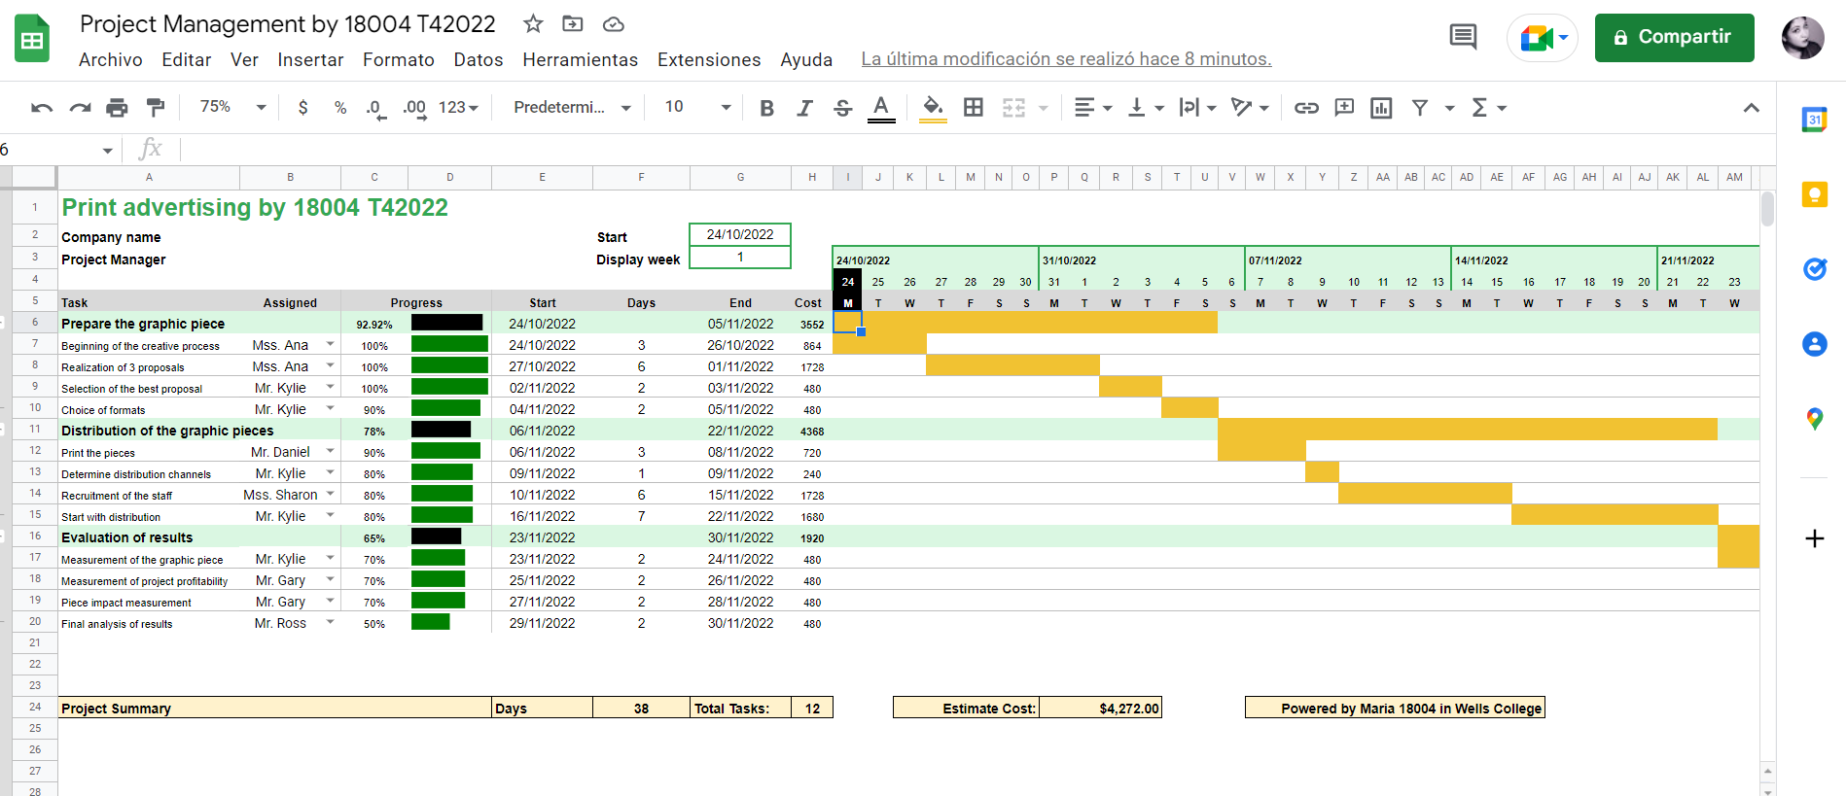

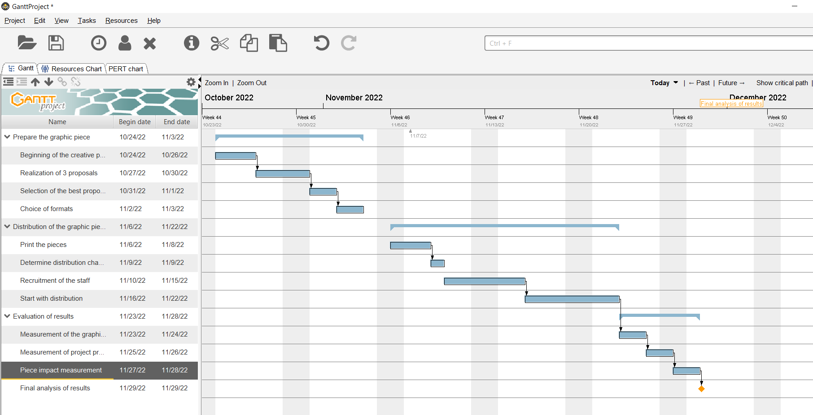

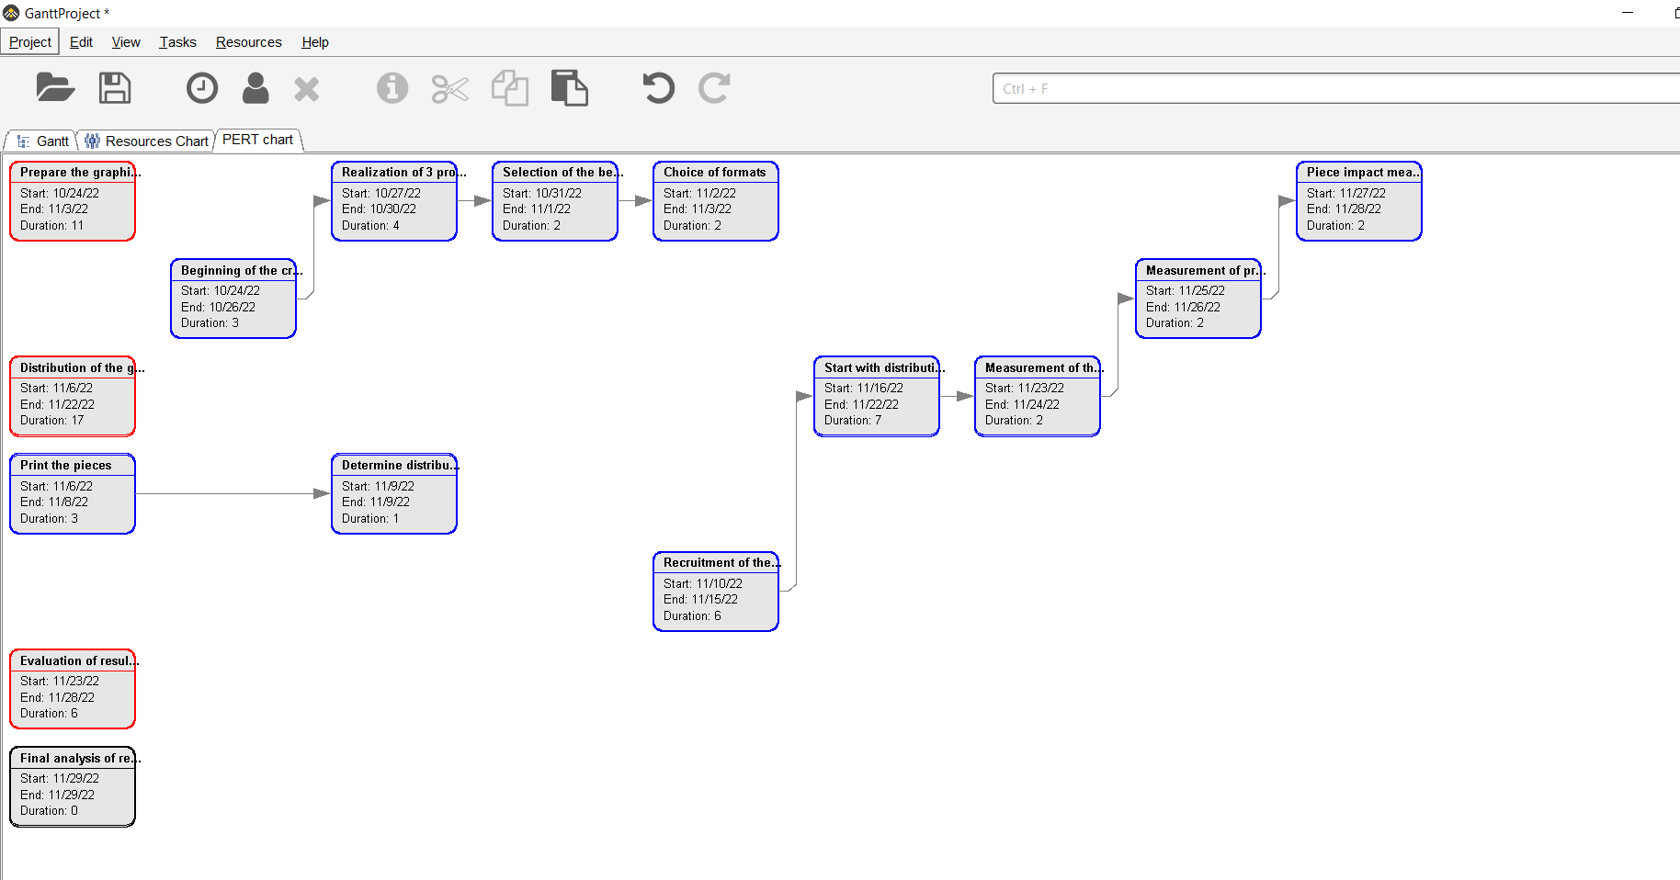

### Business situation

Taking into account the objectives of the case, the budget, and all the content of the project. We made the decision to carry out a graphic advertising campaign aimed at our client so that they can bet on the new "Green IT" service and that they can visualize the effort that the company makes to improve the conditions of our society and even the planet. It is important to be able to highlight the benefits of our way of working compared to other ways. Also be able to highlight the investment that would be achieved with it

## Your tasks:

### Task 1: Identify Business Strategy and Gap

Document the business’s strategies of “Green IT” and also summarise the components required changes for the participating organisation to implement “Green IT Project”. (Min. 300 words)

Business strategy is a planning function of any organisation. Business strategy incorporates having a strategic plan.

**Analyse Strategy**

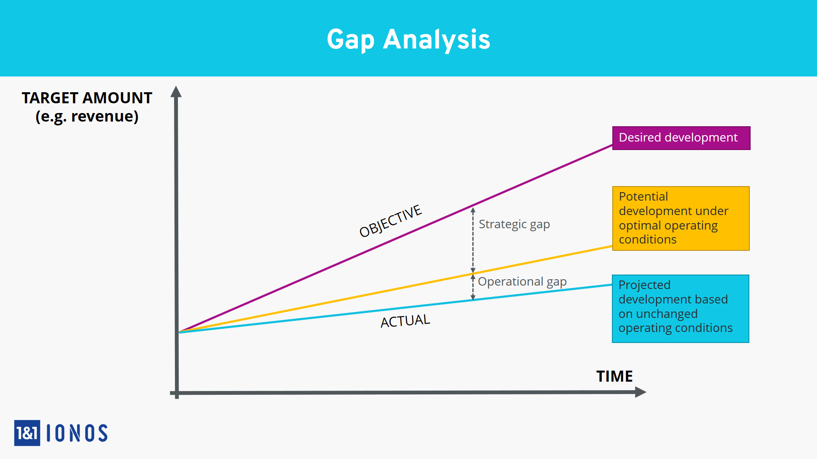**Tracking individual court cases or standalone budget items is operational data and not as helpful for strategic analysis.**While important, operational data as individual items is too detailed to extrapolate into trends or summaries that might shift an organization’s strategy.

The green project we need defined every requirement. The gap which is between your plan and reality always need your notice. So you need do your best to investigate your Green Project.

### Task 2: Recommend a feasible solution

Assume “IT FUTURE COMPANY” “Green IT” and asked for your assistance in this project. Research different project management applications on the Internet to compare with the Green IT project management application and recommend a feasible solution with proper reasons for Windsor. (Min. 300 words)

* Carry out the creative process to make the graphic piece to start with the advertising campaign.
* Proceed with the printing of each of the pieces for later distribution. take into account that the quantity of the same has to be superior to that of the distribution so that there are enough copies
* Carry out the distribution of copies taking into account the distribution channels and the budget
* Finally carry out the analysis of the results with a survey that helps us to visualize the impact

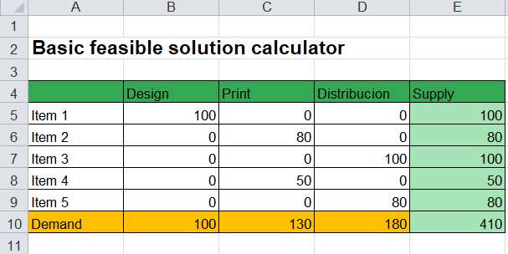

### Task 3: Produce a Project Charter

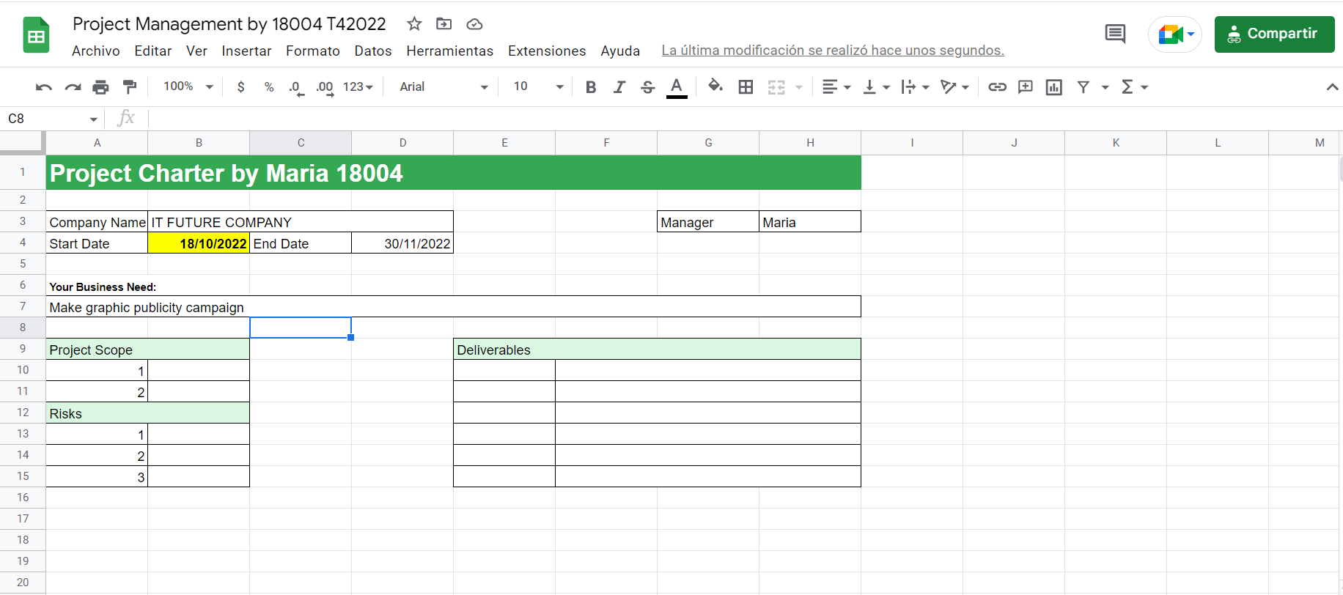

Develop a project charter for the Windsor project specifying project start date, finish date, approximate budget, project manager, project team with roles and responsibilities, project objective, project approach and stakeholders.

Name: IT FUTURE COMPANY

Description: Make a graphic publicity campaign

Manager: Maria

Date Approved: 18/10/2022

### Task 4: Project Document

Please check my site: <https://maria191219.github.io/PM18004T32022/>

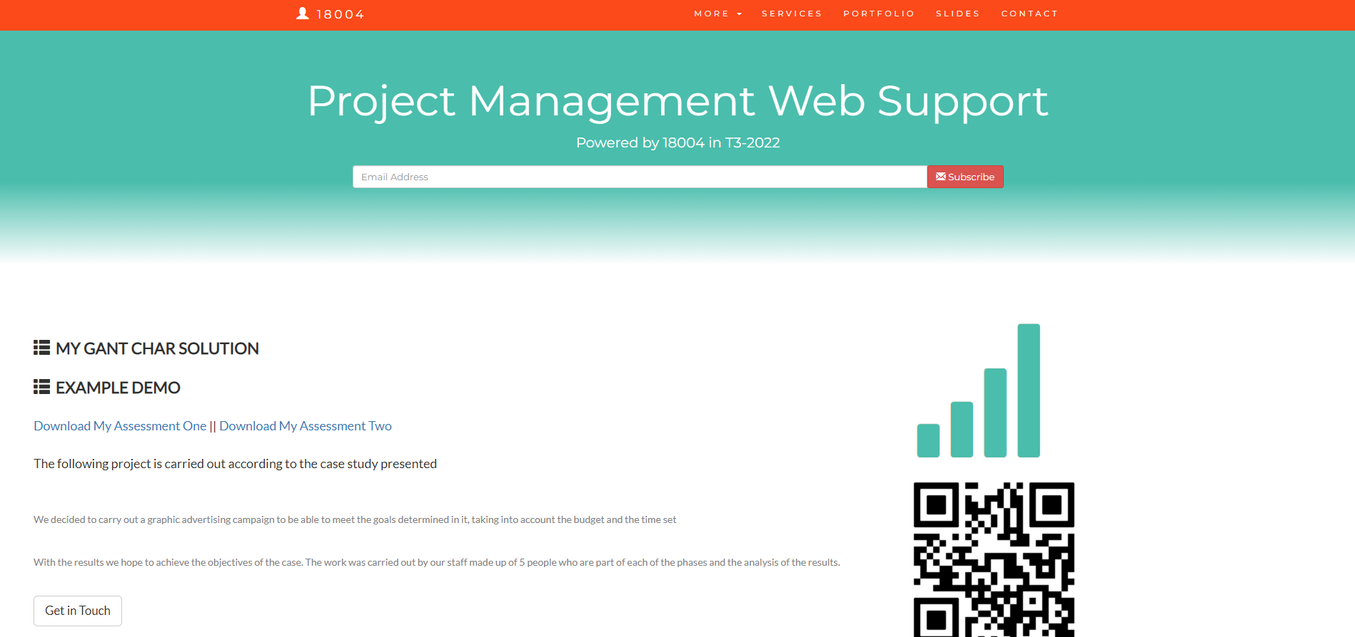

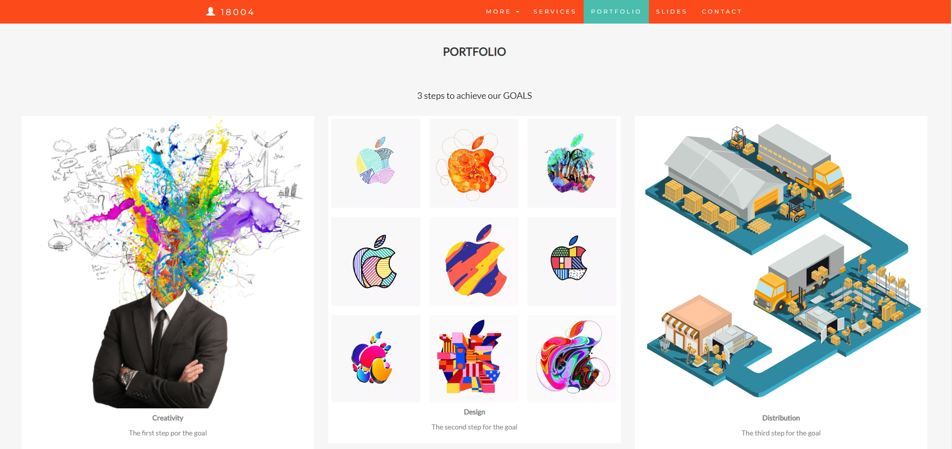

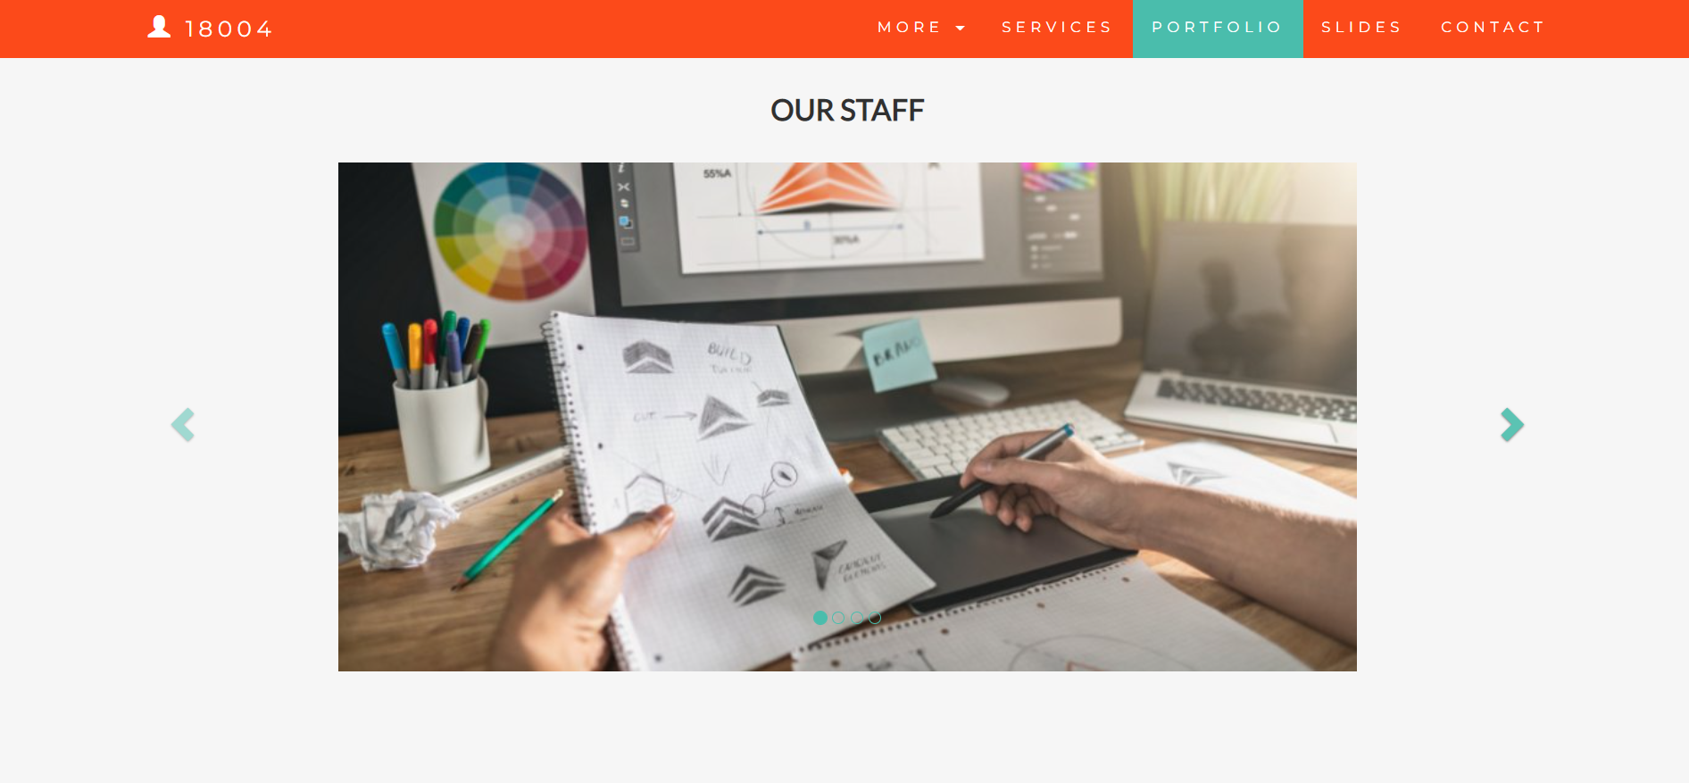

Refer to your current project, you have been asked to develop a project plan for WIC. Project plan outline as following:

In my Green project, I design following topics:

* **Introduction**

In the project we carried out a graphic design campaign to be able to make the public aware of the benefits of Green It.

Because it is important for companies to be aware of this issue. It is not something that has been widely publicized.

* **Project background**

In 1992, the U.S. Environmental Protection Agency launched Energy Star, a voluntary labeling program that is designed to promote and recognize the energy efficiency in monitors, climate control equipment, and other technologies. This resulted in the widespread adoption of sleep mode among consumer electronics. Concurrently, the Swedish organization TCO Development launched the TCO Certified program to promote low magnetic and electrical emissions from CRT-based computer displays; this program was later expanded to include criteria on energy consumption, ergonomics, and the use of hazardous materials in construction.

* **Related factor to organization**

The organization is a company dedicated to IT services for private and public companies. Seeking that their clients have constant help and guidance

* **Scope and objective of the project**

Make our clients aware of the benefits of Green IT

* **Information gathering plan and approach**

The information will be collected through surveys and questionnaires towards our clients when the campaign has finished reviewing the impact.

* **Interview**

We will conduct an interview with one of our clients to measure the impact. Asking a question about understanding the advertising piece

* **Questionnaire**

The questionnaire will have 6 open questions specifically formulated to achieve the objectives

* **Observation**

We will carry out observational research to see our client's reaction to advertising.

* **Detail of information repositories**

In information technology, a repository is a central place in which an aggregation of data is kept and maintained in an organized way, usually in computer storage.

* **Technical**

Need higher tech made this software more stable and powerful

* **Operational**

There are operational advantages in putting sales and admin in the same building.

* **Economical**

Giving good value or return in relation to the money, time, or effort expended.

* **Social**

Relating to society or its organization

* **Project plan and schedule**

Our project schedule is specified in our grant chart. It is proposed in a short period taking into account the budget

* **Work breakdown structure**

It is the tool that utilizes this technique and is one of the most important project management documents. It singlehandedly integrates scope, cost and schedule baselines ensuring that project plans are in alignment.

* **Gantt Chart**

A chart in which a series of horizontal lines shows the amount of work done or production completed in certain periods of time in relation to the amount planned for those periods.

* **Milestone**

A milestone chart is a horizontal chart that marks the most important steps of the project. In this case our milestone is become in the important company of Green It in the world

* **Communication plan**

Our communication plan is basically raised by a graphic campaign. later it could be raised digitally

* **Recourse and budget**

Budget has been limited by IT FUTURE COMPANY is of $1,200,000

* **Risk Managemen**t

Our risk is that the determined deadlines cannot be met. Another risk to take into account is that the costs exceed the budget

* **Contingency plan**

In case the objectives have not been achieved, we will make a digital campaign with the same piece to minimize costs.

### 

### Task 5: Project Closure

Prepare project closure document template as following:

* Project Sign-off document

When project sign off, it means your project finished. So you need make one clear sheet to tell everyone about your project. It will include:

* project start date
* project manager
* project finish date
* if something is going wrong
* ...

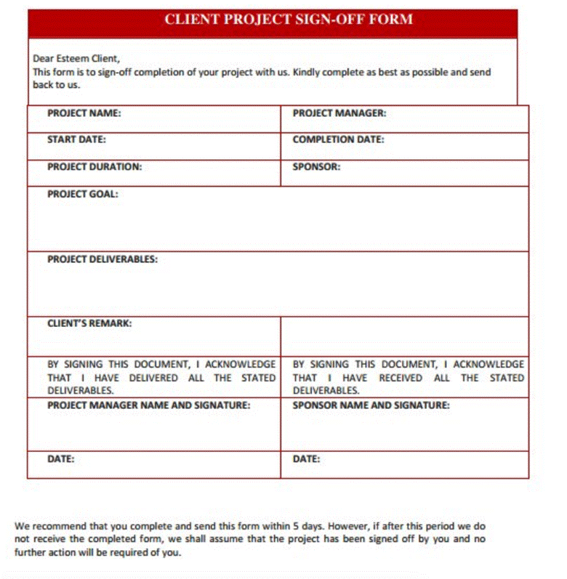

* Project evaluation document

You need show about your project, good or not enough. Summary all about your project

It may include:

* Budget evaluation
* Quality evaluation
* Benefit evaluation
* Etc...

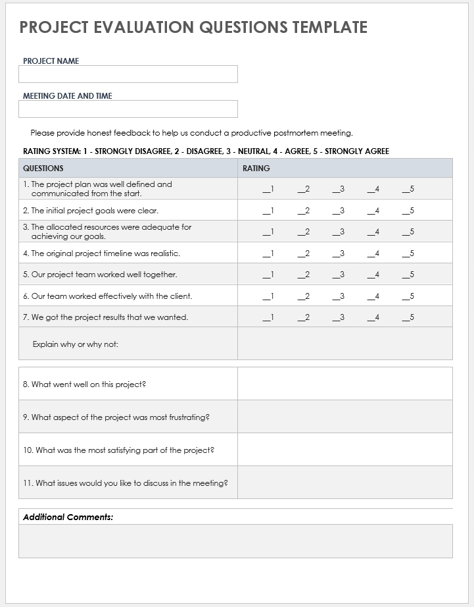

* Lesson learned template
* What we have learn through this project
* What we need to do if next project start
* What we learn some lesson. We could not make same mistake again.
* Etc.

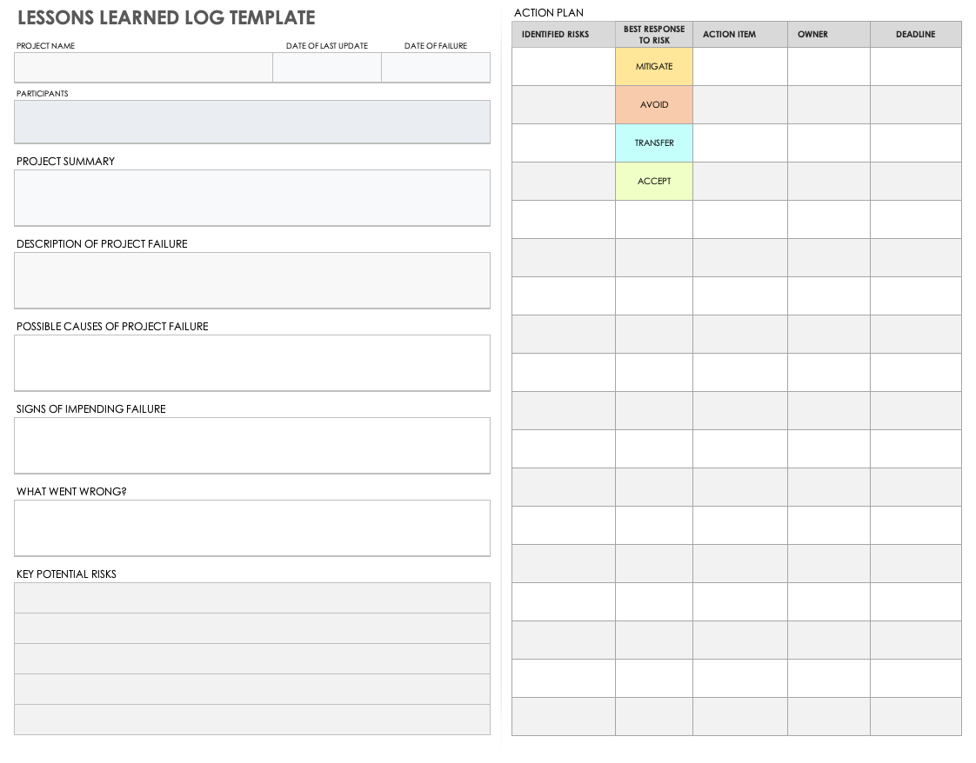

## Helpful web links to complete the assessment:

## Search Index

B

Benefit evaluation 10

Budget evaluation 10

F

feasible solution 1, 4

P

project sign off 9

Q

Quality evaluation 10

S

same mistake 10

scenario 1

specific focus 2